Dis-US-OK-Arkansas R., Tulsa Co., Pleistocene *Bison antiquus* Mandibles-same animal

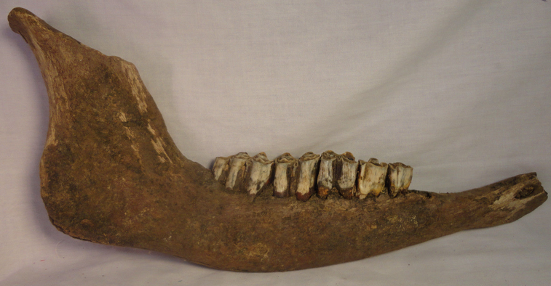 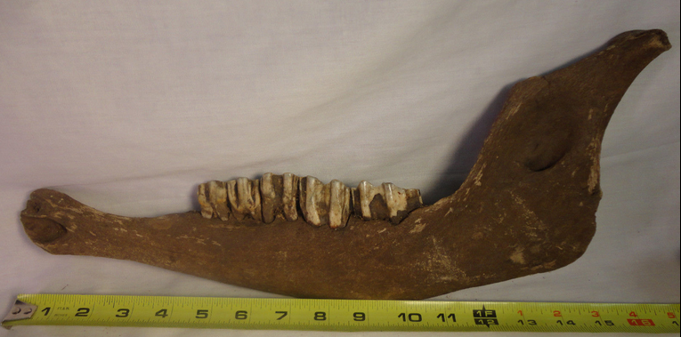

Figs. 1-2. Pleistocene *Bison antiquus* right mandible, lateral views.

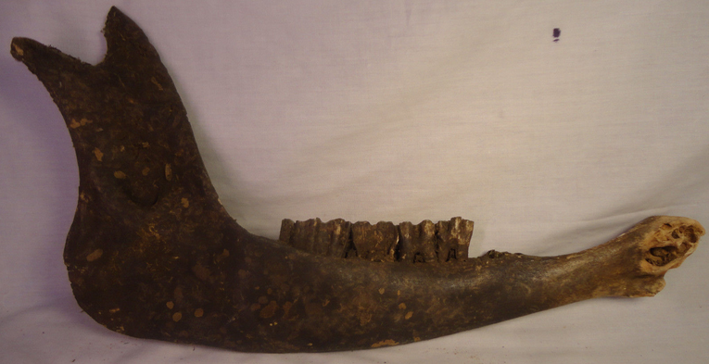 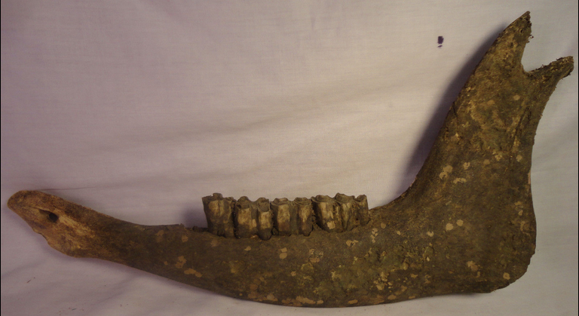

Figs. 3-4. Pleistocene Bison left Mandible, lateral views.

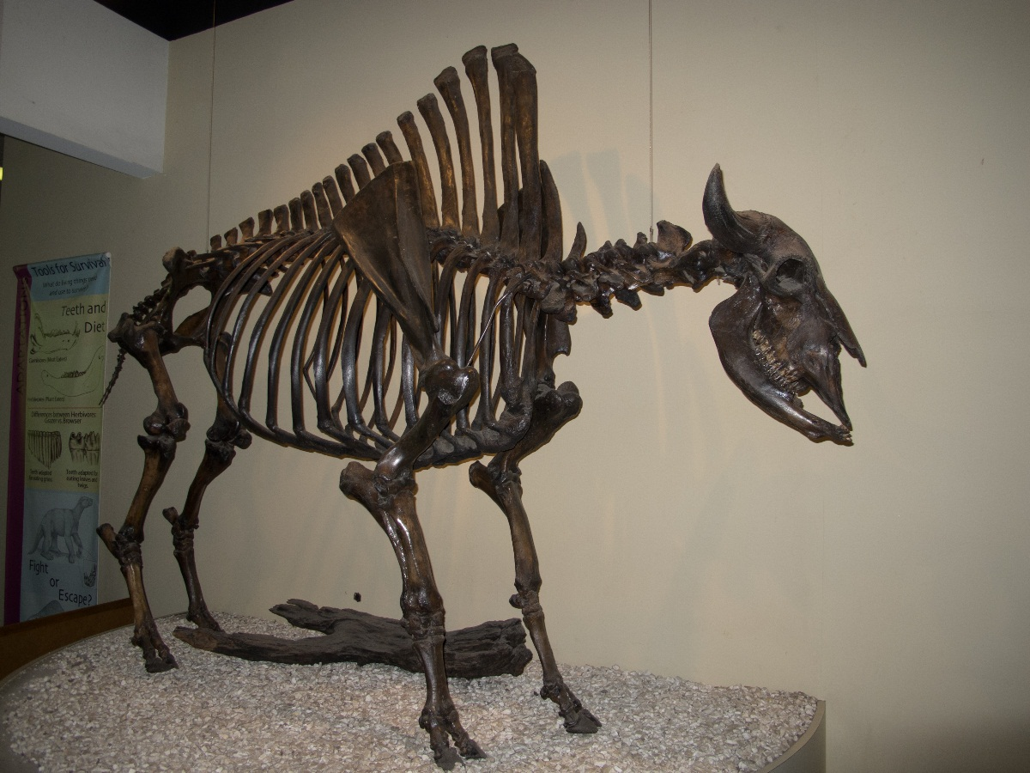

Fig. 5. *Bison antiquus*, La Brea Tar Pits, Museum of Natural History, Los Angeles.

After [Ed Bierman](http://www.flickr.com/people/26216388@N02) from CA, usa.

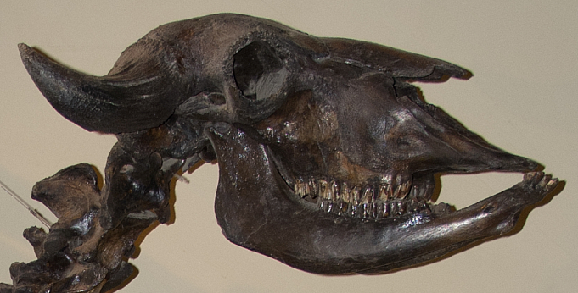

Fig. 6. Skull of *Bison antiquus*, showing the emplacement of the lower mandible, specimen from the La Brea Tar Pits, Los Angeles Museum of Natural History. Photograph after [Ed Bierman](http://www.flickr.com/people/26216388@N02) from CA, usa.

**Formal Label: Oklahoma, Arkansas River, Tulsa County,** Pleistocene *Bison antiquus* Mandibles, both sinister and dexter (left and right) same animal.

**Accession Number:**

**LC Classification:**  [QE746.G466](http://librarycatalog.unh.edu/search%7ES5?/fQE746+.G466+2008/fqe++746+g466+2008/-3,-1,,B/browse)

**Date or Time Horizon:** 18,000-10,000 BP

**Geographical Area:** **Oklahoma, Arkansas River, Tulsa County.**

**Cultural Affiliation:** Pleistocene.

**Medium:** Original Fossil.

**Dimensions: L >16 in  
Weight:**

**Provenance: Don Devay, Broken Arrow, OK.**

**Condition:** Museum quality, both mandible of same animal

**Discussion:** During the later Pleistocene epoch, between 240,000 and 220,000 years ago, steppe *B. priscus* migrated from Siberia into Alaska (Bell et alii 2004: 232–314; Scott and Cox 2008: 359–382; Sanders, A.E.; R.E. Weems & L.B. Albright III 2009: 369–375). This species migrated into northern North America and remained there for the Pleistocene, but in the midcontinent of North America the long-horned *B. latifrons* evolved from *B. priscus,* and then *B. antiquus* evolved from *B. latifrons* and overtook both from 18,000 BP until about 10,000 BP (Scott and Cox 2008: 359–382),after which it evolved into the living *B. bison* (Wilson, Hills, Shapiro 2008). *B. antiquus* was taller, had larger bones and horns, and was 15-25% larger than *B. bison* attaining a height of 2.27 m (7.5 ft), a length of 4.6 m (15 ft) long, and a weight of 1,588 kg (3500 lb). From tip to tip, the horns of *B. antiquus* measured about 3 ft (nearly 1 m).

**References:**

Bell, C.J.; et al. 200*4. "*The Blancan, Irvingtonian, and Rancholabrean mammal ages*".* InWoodburne, M.O. *Late Cretaceous and Cenozoic Mammals of North America: Biostratigraphy and Geochronology.* New York: Columbia Univ. Press.

Scott, E.; Cox, S.M. 2008*. "Late Pleistocene distribution of Bison (Mammalia; Artiodactyla) in the Mojave Desert of Southern California and Nevada".* In Wang, X.; Barnes, L.G., *Geology and Vertebrate Paleontology of Western and Southern North America*. Los Angeles: Natural History Museum of Los Angeles County*.*

Sanders, A.E.; R.E. Weems & L.B. Albright III. 2009*. "*Formalization of the mid-Pleistocene "Ten Mile Hill beds*" in South Carolina with evidence for placement of the Irvingtonian–Rancholabrean boundary".* In Albright III, L.B. *Papers on Geology, Vertebrate Paleontology, and Biostratigraphy in Honor of Michael O. Woodburne*. Flagstaff: Museum of Northern Arizona*.*

Wilson, M.C. & L.V. Hills, B. Shapiro (2008). "Late Pleistocene northward-dispersing Bison antiquus from the Bighill Creek Formation, Gallelli Gravel Pit, Alberta, Canada, and the fate of Bison occidentalis," Canadian Journal of Earth Sciences, **45** (7): 827–859.